James Keller – GES408 – R Lab
Part 1
Data Exploration: What are the mean counts inside and outside the reserve? What are the standard deviations? (1 point)
Reserve Status | Mean | Standard Deviation
Inside | 20.45 | 4.058
Outside | 18.4 | 3.152

Make a very simple boxplot for visual comparison: Do the data appear normally distributed? Do the distributions look similar? (1 point)
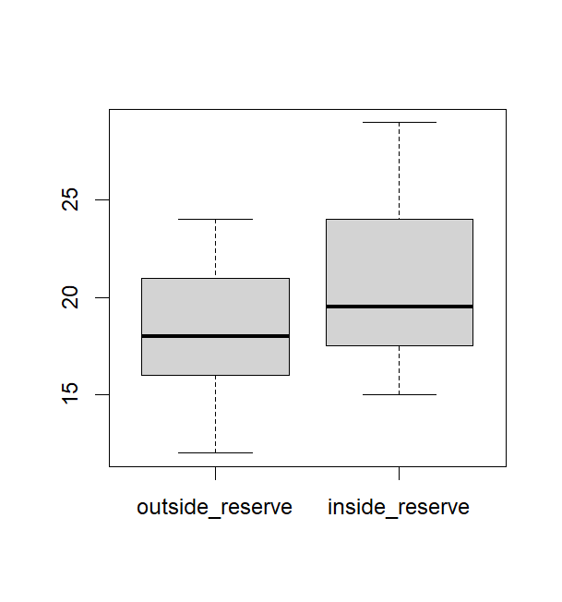
The distributions do look similar but they are not identical. The data does seem normally distributed.
Run a t-test and report the relevant results. What can you infer about how effective the reserves are? (2 points)
T value | Degrees of Freedom | p-value | Confidence Interval
3.2313 | 19 | 0.004395 | 0.7221, 3.3779
From this, we can infer that the reserves are having an effect on abalone populations.
Part 2
Data Exploration: What are the mean lengths of Yellowfish in each location? What are the variances? Do they meet the assumption of equal variances with a formal test? (2 points)Hint: One of the easiest ways to get separate means and variances in this case may be with the filter function.
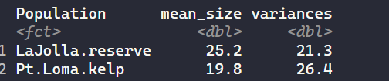
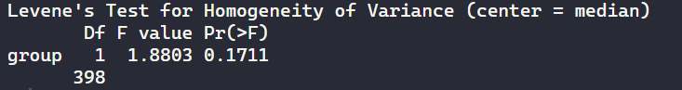
Our data suggests that there is not statistically significant evidence that the variances differ between the populations.

Create a simple boxplot to visually compare the treatments. (1 point)Hint: with your original data frame, you can use ggplot, or you can try base R. Make a histogram of yellowfish size subsetted by the population they are from. Does the data appear normally distributed? Can you test this formally? (2 points)
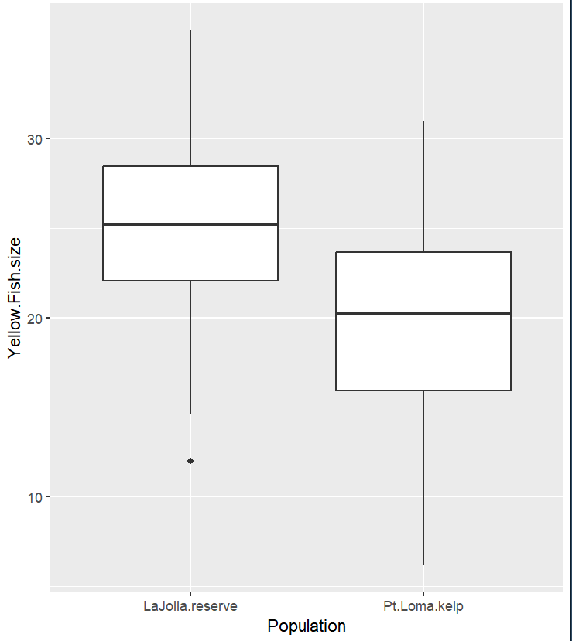
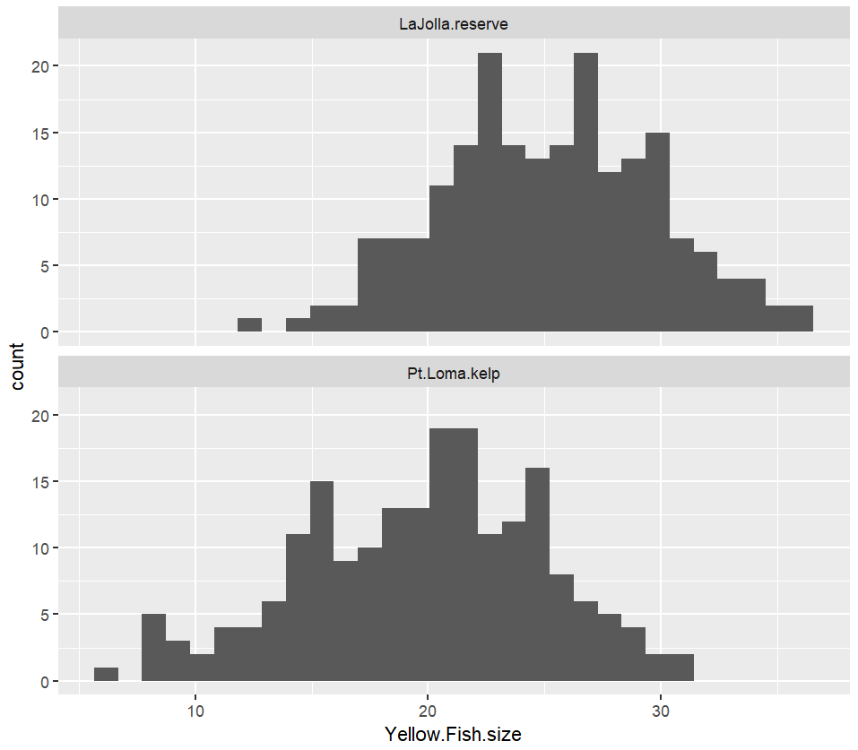
This data does seem to be normally distributed. We can test this formally using the Shapiro-Wilk test.
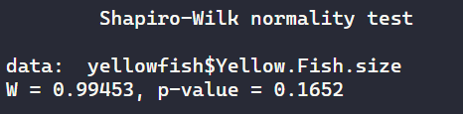
According to the Shapiro-Wilk test, our data is normally distributed.

Run a t-test and report the relevant results. What can you infer about the Yellowfish populations? (2 points)
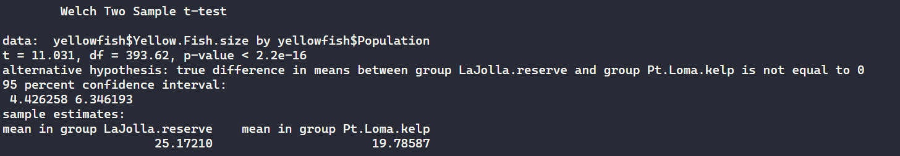
The p-value for the t-test is much less than 0.05 which supports the alternative hypothesis that the size of the fish is different depending on which reserve it is from.
ANOVA
Create a simple boxplot of the bacteria levels by treatment group (beach). Do any of the beaches appear different from the others? (1 point)
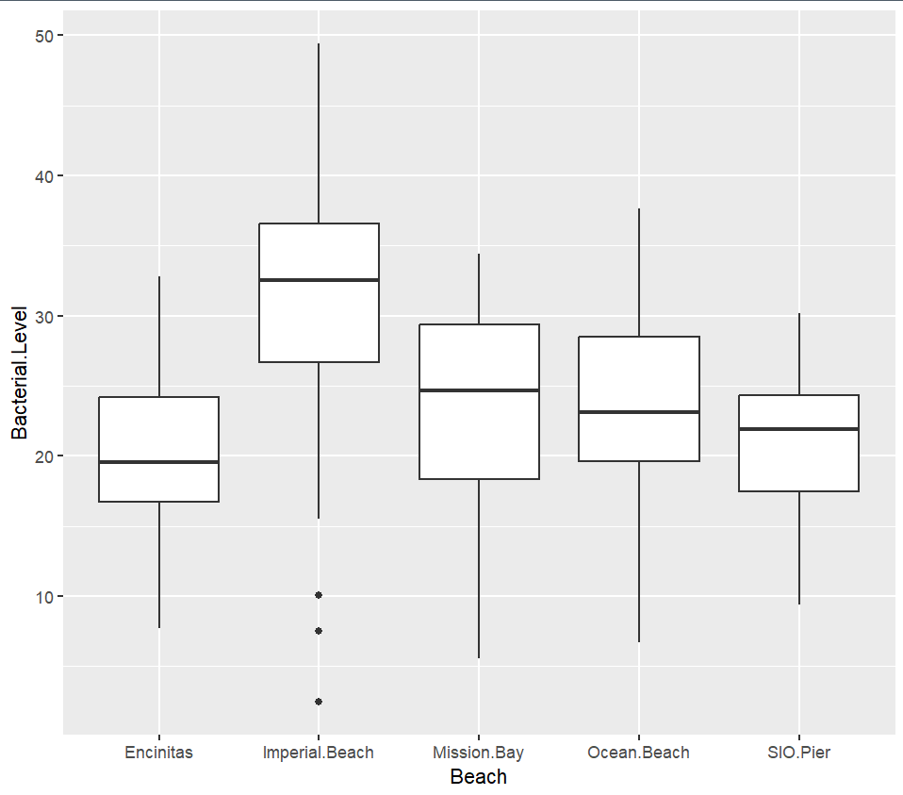
Imperial beach appears to have elevated bacterial levels compared to the others.

Create the ANOVA model and run it. Report the pertinent results. (1 point)
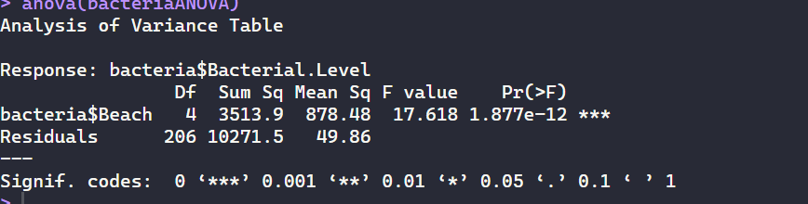
There appears to be at least one group that is statistically significant from the others.
Now let’s run a post-hoc test to see which treatment(s) are driving any patterns we observe (Tukey-Kramer test). Report and discuss your results. (1 point)
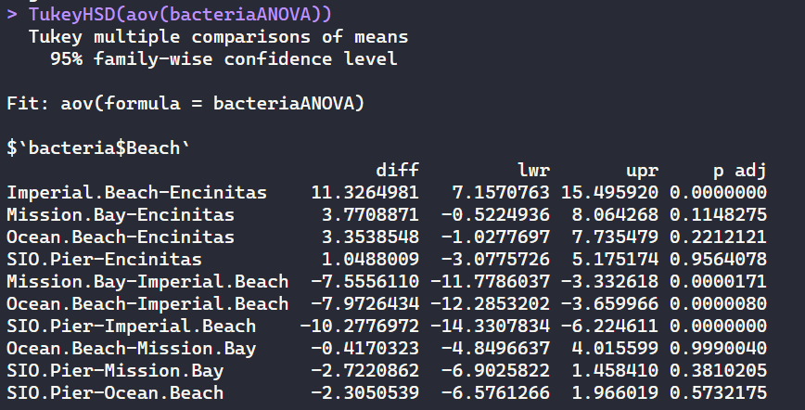
The significant results from our Tukey-Kramer test is that Imperial Beach and Encinitas beach differ from each other significantly.

Regression
Take a closer look at your data, using a correlation table and other things if you so choose. Which variables seem to be most strongly correlated? (1 point)
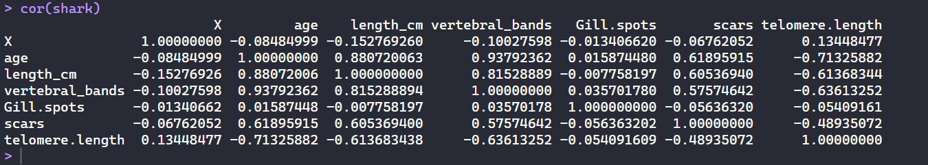
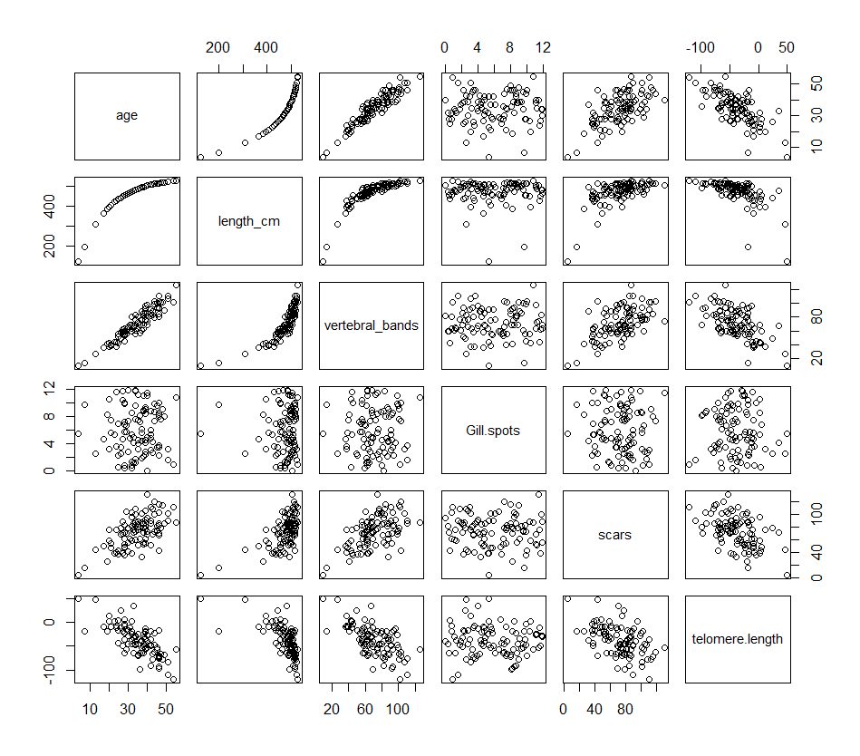
The variables that seem to be the most correlated are Age and Length_cm, Age and vertebral_bands.
Pick 2 of these predictor variables for age and create a model with them. Check assumptions(residuals vs. fitted, qqplot, VIF), and report the relevant results. (1 point)
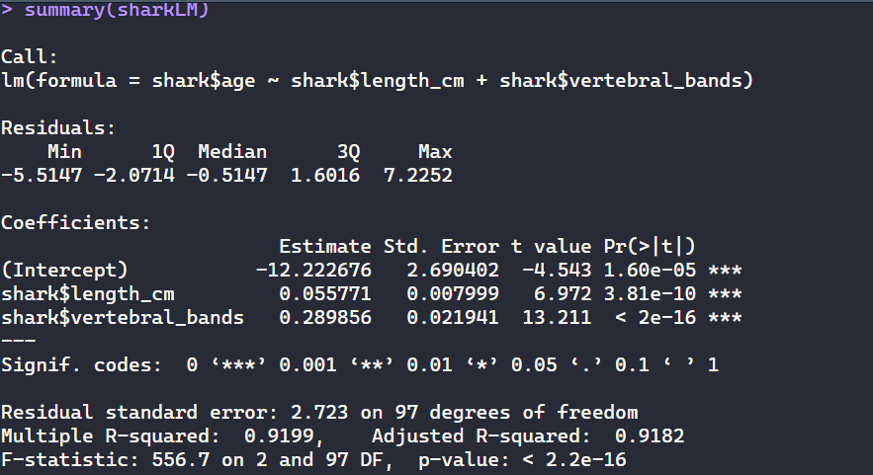
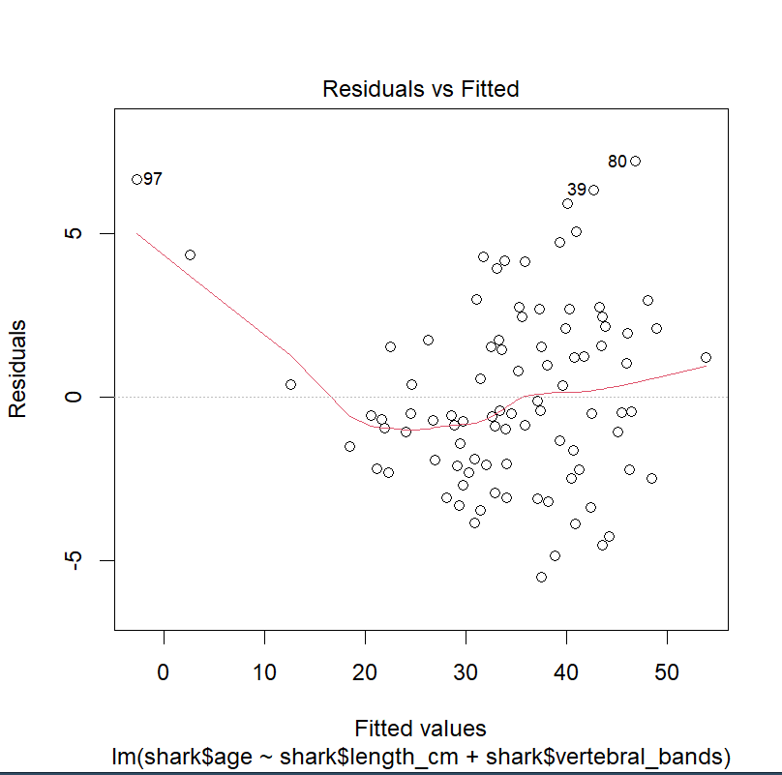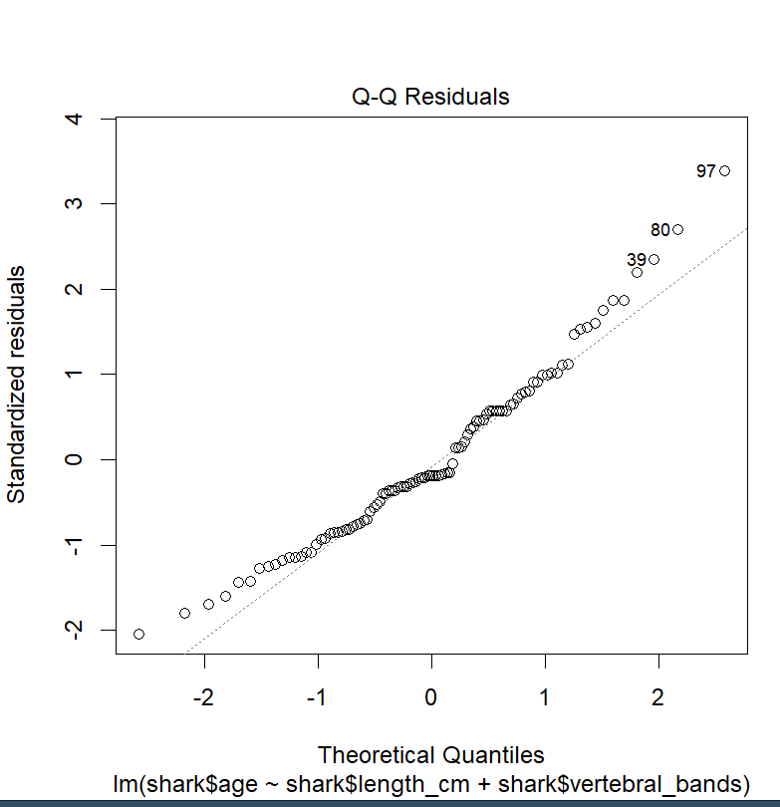
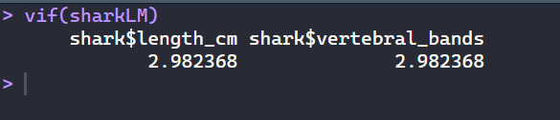
For this model, our adjusted R^2 is 0.91 which indicates a strong correlation between our two predictors (length_cm and vertebral_bands) and a shark’s age. We also have a p-value much less than 0.05 which implies that there is strong evidence that length and vertebral bands are predictors of shark age. With a VIF score of 2.98, multicollinearity is possible for the predictors but is not enough to be certain.
Add another 2 predictor variables to a second model. Check assumptions, and report the relevant results, comparing them to the first model you made. (2 points)
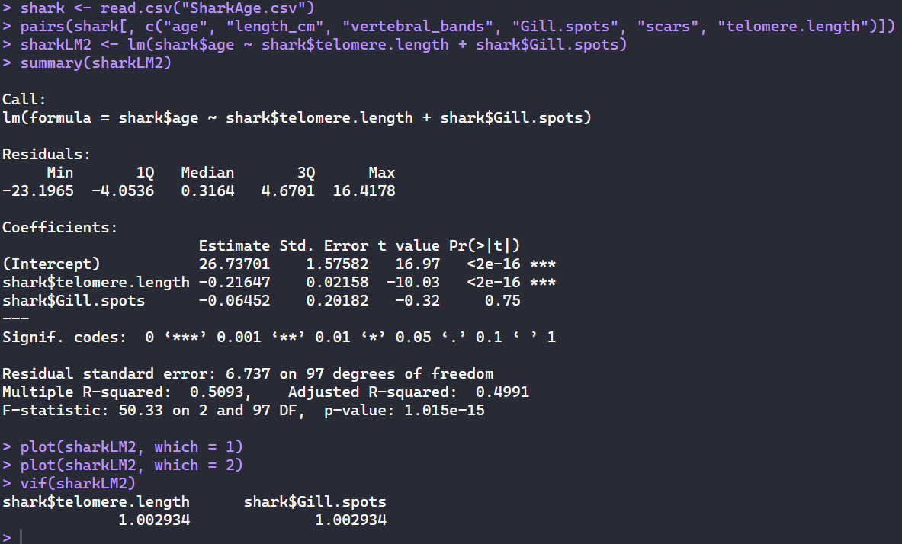
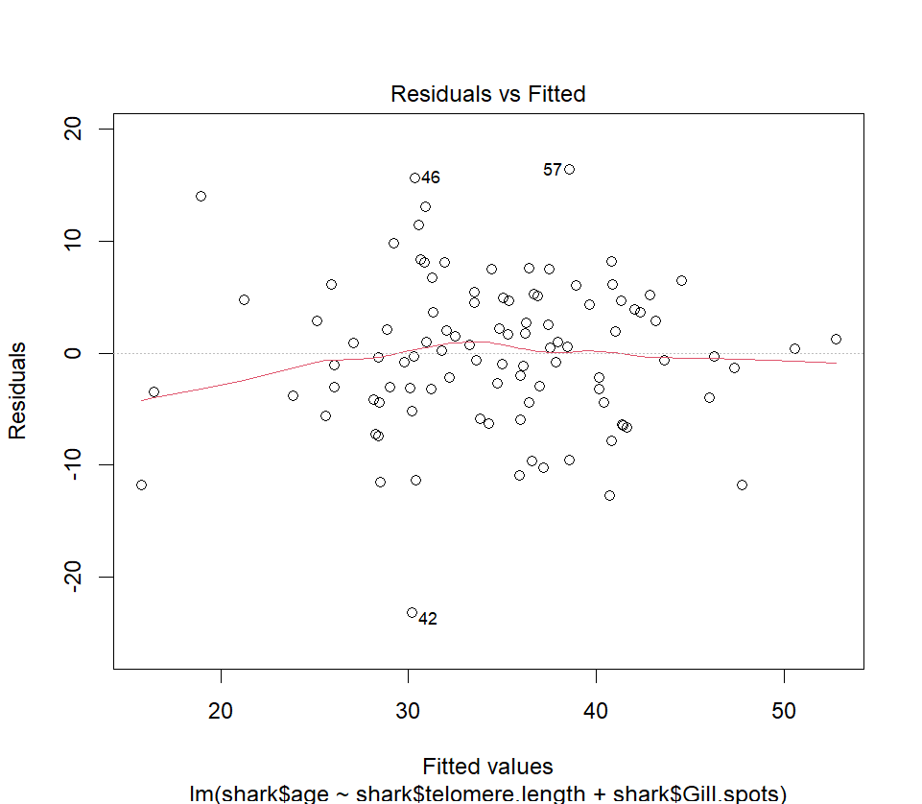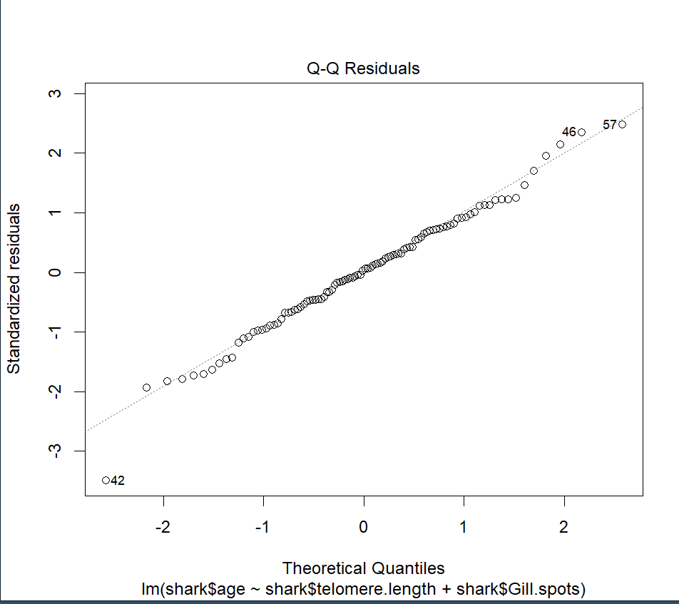
For this second model, our adjusted R^2 is 0.499 which indicates a correlation between our two predictors (gill.spots and telomere.length) and a shark’s age. We also have a p-value much less than 0.05 but the p-value for telomere length alone is less than 2e^-16 and the p-value for gill spots alone is 0.75. This implies that while the overall model is statistically significant, this is due to telomere length alone.

Compare the AIC values of your models. According to this, which one would you use? (1 point)
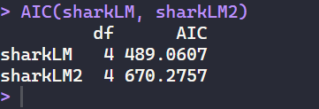
According to our AIC values of the models, I would use model 1 (sharkLM) because its AIC value is lower than that of the other model.

Choose A SINGLE explanatory variable to make a scatterplot with comparing it to the age of a shark. Make sure to add in a trendline. This is just for practice editing the code, so it doesn’t matter which one of the explanatory variables it is - pick your favorite! (1 point)
